Class Assignment 3

Create html page like this

<!DOCTYPE html>

<HTML>

<head>

</head>

<body>

<h1>Please join our email list</h1>

<form id="email_form" name="email_form">

<label>Email Address:</label>

<input type="text">

<span>*</span><br>

<input type="button" id="join_list" value="Join our List" onclick="ValidateMe();">

</form>

</body>

</HTML>

Write Javascript code which will check if the textbox is empty.

If the text box it empty span will display “Enter Email Address” in Red Color otherwise the span will be empty.

**How to submit:**

Compress the folder.

Take Screen Shots of your HTML, CSS, and JavaScript codes attach those to this file.

Upload the compressed folder and word document in moodle.

**Answer here:**

**Code:**

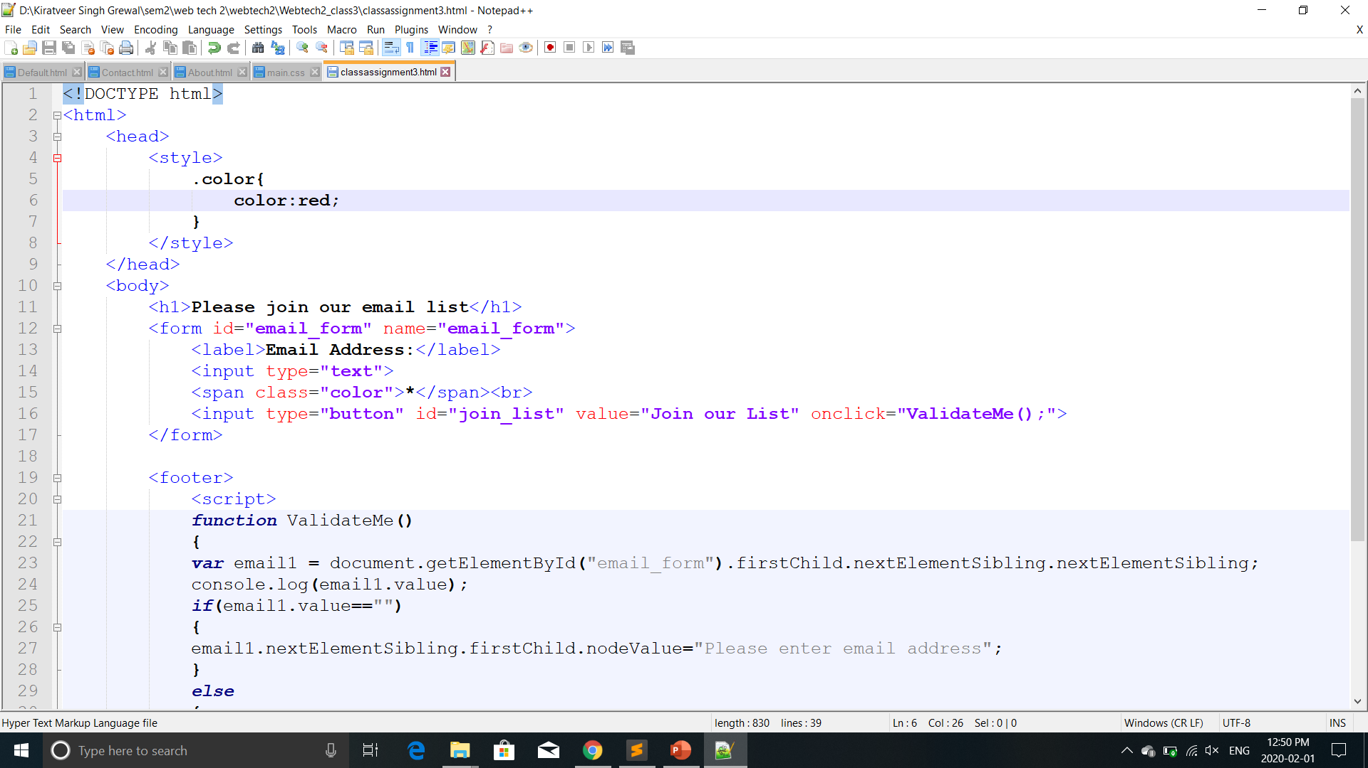 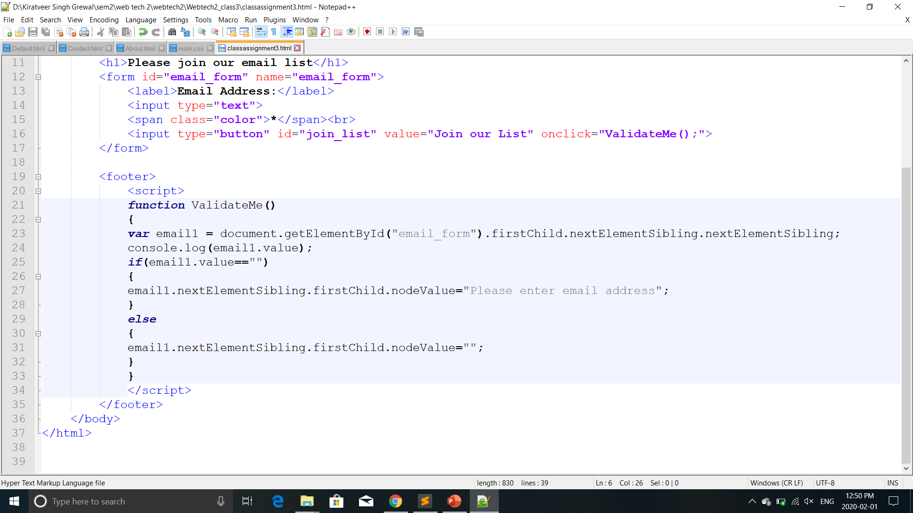

**Output:**

